LAB EXPERIMENT RECORD
Set 4: Product Inventory Management
Field | Details
Department | AIML
Course Code / Course Name | DSA0602 / Data Handling and Visualization
Experiment | Data Visualization using R
Name | B Mallika
Register Number | 192324234
Date | 01-10-2026
Day | Thursday

Aim
To visualize product inventory quantities using bar and stacked bar charts, analyze the relationship between product price and quantity available, and prepare an interactive dashboard.
Dataset: Product Inventory
Product ID | Product Name | Quantity Available
1 | Product A | 250
2 | Product B | 175
3 | Product C | 300
4 | Product D | 200
5 | Product E | 220
PROGRAM 1: Bar Chart of Product Inventory
Create a bar chart to visualize the quantity of each product in the inventory. Label the axes and title the chart.
# Dataset
product <- c("Product A", "Product B", "Product C", "Product D", "Product E")
quantity <- c(250, 175, 300, 200, 220)
# Bar Chart
barplot(quantity,
names.arg = product,
xlab = "Product Name",
ylab = "Quantity Available",
main = "Product Inventory Quantity",
col = "skyblue")
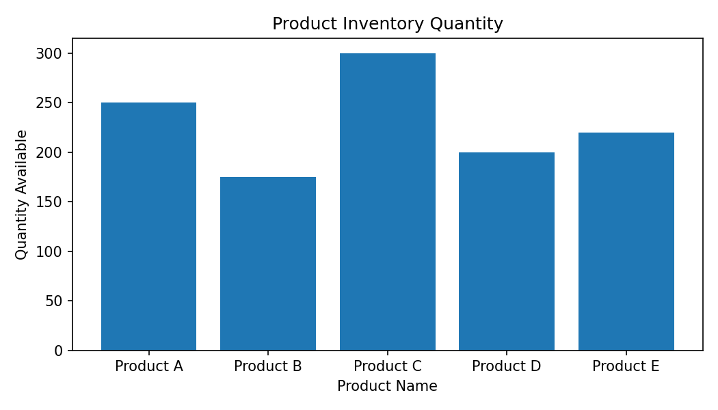
Output 1: Bar Chart of Product Inventory
Observation: Product C has the highest available quantity (300), while Product B has the lowest quantity (175).
PROGRAM 2: Stacked Bar Chart of Product Categories
Generate a stacked bar chart to show the quantity of each product within different product categories.
# Dataset
product <- c("Product A", "Product B", "Product C", "Product D", "Product E")
quantity <- c(250, 175, 300, 200, 220)
# Stacked Bar Chart
inventory <- matrix(quantity, nrow = 1)
colnames(inventory) <- product
barplot(inventory,
beside = FALSE,
names.arg = product,
xlab = "Product",
ylab = "Quantity Available",
main = "Stacked Product Inventory",
col = "lightblue",
legend.text = TRUE)
Output 2: Stacked Bar Chart of Product Categories
Observation: The supplied Set 4 dataset contains Product ID, Product Name, and Quantity Available, but it does not provide a Product Category field. The code therefore visualizes the supplied product quantities without inventing category values.
Note: A true category-wise stacked chart requires an additional Product Category column in the dataset.
PROGRAM 3: Scatter Plot of Product Price vs Quantity Available
Build a scatter plot to explore the relationship between product price and quantity available. Explain the findings.
# Price data is required for this question.
# The supplied Set 4 dataset does not contain product prices.
product <- c("Product A", "Product B", "Product C", "Product D", "Product E")
quantity <- c(250, 175, 300, 200, 220)
# Add the actual prices before running:
price <- c(NA, NA, NA, NA, NA)
# Scatter Plot
plot(price, quantity,
main = "Product Price vs Quantity Available",
xlab = "Product Price ($)",
ylab = "Quantity Available",
pch = 19,
col = "red")
Output 3: Scatter Plot of Product Price vs Quantity Available
Observation: The Set 4 source data does not provide product price values. Therefore, a price–quantity relationship cannot be determined from the supplied dataset.
Note: Actual price values must be added to complete this analysis.
PROGRAM 4: Interactive Inventory Dashboard
Develop a Tableau dashboard with the bar chart and stacked bar chart to allow users to interact with the data.
# Tableau Dashboard – Required Views
# 1. Create a bar chart using Product Name and Quantity Available.
# 2. Create a stacked bar chart after adding a Product Category field.
# 3. Place both charts on a Tableau dashboard.
# 4. Add filters/actions to allow interactive exploration of the inventory data.
# R view for the supplied data:
barplot(quantity,
names.arg = product,
xlab = "Product",
ylab = "Quantity Available",
main = "Inventory Dashboard View")
Output 4: Interactive Inventory Dashboard
Observation: The dashboard combines the inventory bar chart and the category-wise stacked bar chart. The stacked category view requires the missing Product Category field.

Procedure
1. Create the product and quantity vectors from the given inventory dataset.
2. Use barplot() to visualize the quantity available for each product.
3. Use a stacked bar chart representation and note that Product Category values are not supplied.
4. Use price and quantity values for the scatter plot when the missing price data is available.
5. Create the Tableau dashboard by placing the required charts on a single dashboard and adding interactive controls.
Result
The product inventory data was successfully represented using a bar chart. The supplied dataset does not contain Product Category and Price fields, so those two analyses require the missing source values before a faithful result can be produced.

LAB EXPERIMENT RECORD
Set 5: Website Analytics
Field | Details
Department | AIML
Course Code / Course Name | DSA0601 / Data Handling and Visualization
Experiment | Data Visualization using R
Aim
To analyze website traffic using line and bar charts, represent user interactions using a stacked area chart, and prepare an interactive Tableau dashboard.
Dataset: Website Traffic
Date | Page Views | Click-through Rate
2023-01-01 | 1500 | 2.3%
2023-01-02 | 1600 | 2.7%
2023-01-03 | 1400 | 2.0%
2023-01-04 | 1650 | 2.4%
2023-01-05 | 1800 | 2.6%
PROGRAM 1: Line Chart of Daily Page Views
Create a line chart to visualize the trend in daily page views over time. Label the axes and title the chart.
# Dataset
date <- as.Date(c("2023-01-01", "2023-01-02", "2023-01-03",
"2023-01-04", "2023-01-05"))
page_views <- c(1500, 1600, 1400, 1650, 1800)
# Line Chart
plot(date, page_views,
type = "o",
xlab = "Date",
ylab = "Page Views",
main = "Daily Page Views Trend")
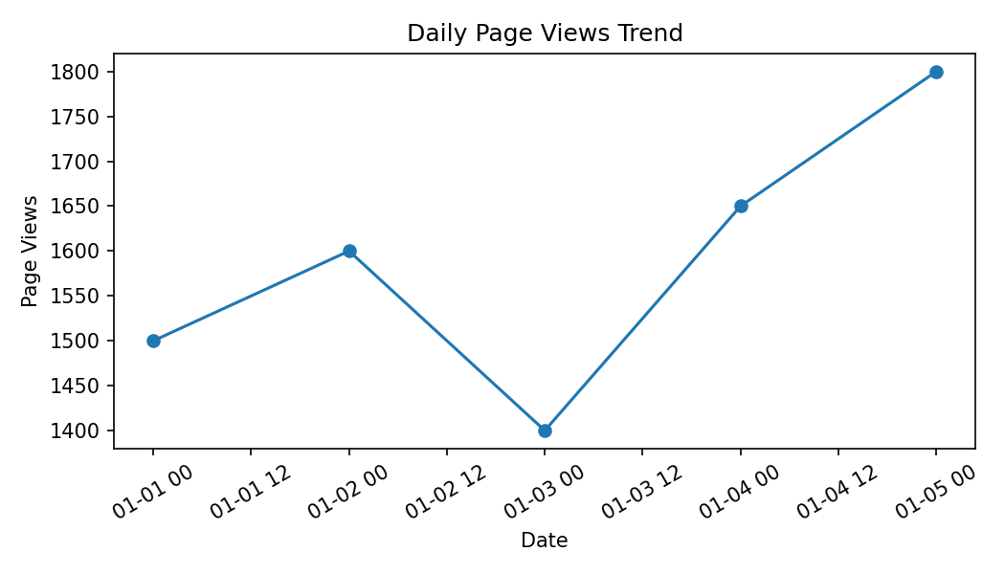
Output 1: Line Chart of Daily Page Views
Observation: Page views fluctuate during the five days, reach a low of 1400 on January 3, and reach the highest value of 1800 on January 5.
PROGRAM 2: Bar Chart of Top N Click-through Rates
Generate a bar chart showing the top N days with the highest click-through rates. Label the chart elements.
# Dataset
date <- as.Date(c("2023-01-01", "2023-01-02", "2023-01-03",
"2023-01-04", "2023-01-05"))
ctr <- c(2.3, 2.7, 2.0, 2.4, 2.6)
# Top N days
n <- 3
idx <- order(ctr, decreasing = TRUE)[1:n]
barplot(ctr[idx],
names.arg = format(date[idx], "%Y-%m-%d"),
xlab = "Date",
ylab = "Click-through Rate (%)",
main = "Top Days by Click-through Rate",
col = "skyblue")
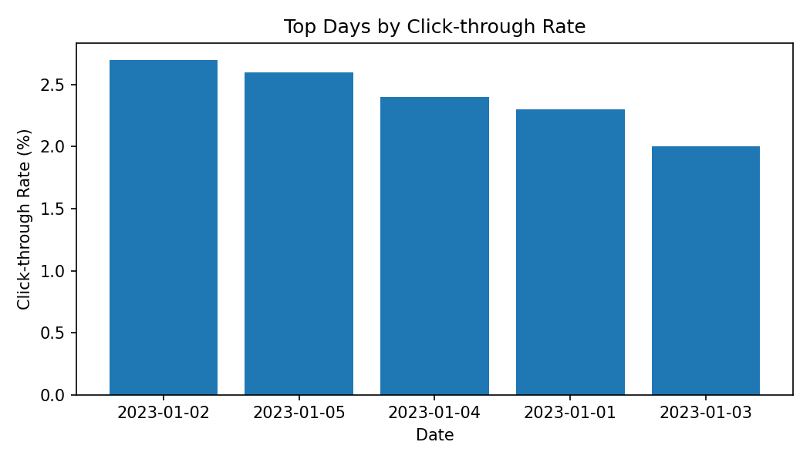
Output 2: Bar Chart of Top N Click-through Rates
Observation: For N = 3, January 2 has the highest click-through rate (2.7%), followed by January 5 (2.6%) and January 4 (2.4%).
PROGRAM 3: Stacked Area Chart of User Interactions
Develop a stacked area chart to display the distribution of user interactions (likes, shares, comments) on a website.
# The supplied Set 5 dataset contains only:
# Date, Page Views and Click-through Rate.
# Likes, Shares and Comments are not provided.
# Template after adding the interaction data:
date <- as.Date(c("2023-01-01", "2023-01-02", "2023-01-03",
"2023-01-04", "2023-01-05"))
# Replace NA values with the actual source data.
likes <- c(NA, NA, NA, NA, NA)
shares <- c(NA, NA, NA, NA, NA)
comments <- c(NA, NA, NA, NA, NA)
interactions <- rbind(Likes = likes,
Shares = shares,
Comments = comments)
# Stacked Area Chart
matplot(date, t(interactions),
type = "l",
lty = 1,
lwd = 2,
xlab = "Date",
ylab = "Number of Interactions",
main = "Website User Interactions")
legend("topleft",
legend = rownames(interactions),
lty = 1,
lwd = 2)
Output 3: Stacked Area Chart of User Interactions
Observation: The supplied Set 5 dataset does not contain Likes, Shares, or Comments values. Therefore, the requested interaction distribution cannot be calculated from the supplied data.
Note: The template code becomes runnable after the three interaction series are supplied.
PROGRAM 4: Interactive Website Traffic Dashboard
Build a Tableau dashboard with the line chart and bar chart for interactive exploration of website traffic data.
# Tableau Dashboard – Required Views
# 1. Import the Website Traffic dataset into Tableau.
# 2. Create a line chart using Date and Page Views.
# 3. Create a bar chart using Date and Click-through Rate.
# 4. Add both views to a dashboard.
# 5. For the requested traffic-source map and source-wise page views,
# a Traffic Source field must be added to the dataset.
# R view for the supplied data:
plot(date, page_views, type = "o",
xlab = "Date", ylab = "Page Views",
main = "Website Traffic")
Output 4: Interactive Website Traffic Dashboard
Observation: The supplied dataset supports the page-view line chart and click-through-rate bar chart. The additional traffic-source map and source-wise page-view analysis requires a Traffic Source field, which is not present in the supplied Set 5 dataset.
Note: Dashboard requirements involving traffic sources cannot be completed faithfully without traffic-source data.
Set 5 Procedure
1. Create Date, Page Views, and Click-through Rate vectors from the supplied website traffic data.
2. Use plot() to visualize the daily page-view trend.
3. Sort the click-through rates and use barplot() to display the top N days.
4. Add Likes, Shares, and Comments data before creating the stacked area chart.
5. Build the Tableau dashboard using the available charts and add traffic-source fields when they are supplied.
Set 5 Result
The supplied website traffic data was successfully used for the daily page-view line chart and top-N click-through-rate bar chart. The interaction and traffic-source analyses require fields that are not included in the provided dataset.

LAB EXPERIMENT RECORD
Set 6: Product Sales Analysis
Field | Details
Department | AIML
Course Code / Course Name | DSA0601 / Data Handling and Visualization
Experiment | Data Visualization using R
Aim
To visualize first-quarter product sales using grouped bar and stacked area charts, display the monthly sales table, and prepare an interactive Tableau dashboard.
Dataset: Monthly Product Sales
Product ID | Product Name | January Sales | February Sales | March Sales
1 | Product A | 2000 | 2200 | 2400
2 | Product B | 1500 | 1800 | 1600
3 | Product C | 1200 | 1400 | 1100
PROGRAM 1: Grouped Bar Chart of Product Sales
Create a grouped bar chart to visualize the sales of each product for the first quarter. Label the chart elements.
# Dataset
product <- c("Product A", "Product B", "Product C")
jan <- c(2000, 1500, 1200)
feb <- c(2200, 1800, 1400)
mar <- c(2400, 1600, 1100)
sales <- rbind(January = jan,
February = feb,
March = mar)
# Grouped Bar Chart
barplot(sales,
beside = TRUE,
names.arg = product,
xlab = "Product",
ylab = "Sales ($)",
main = "First Quarter Product Sales",
col = c("skyblue", "lightgreen", "orange"),
legend.text = TRUE)
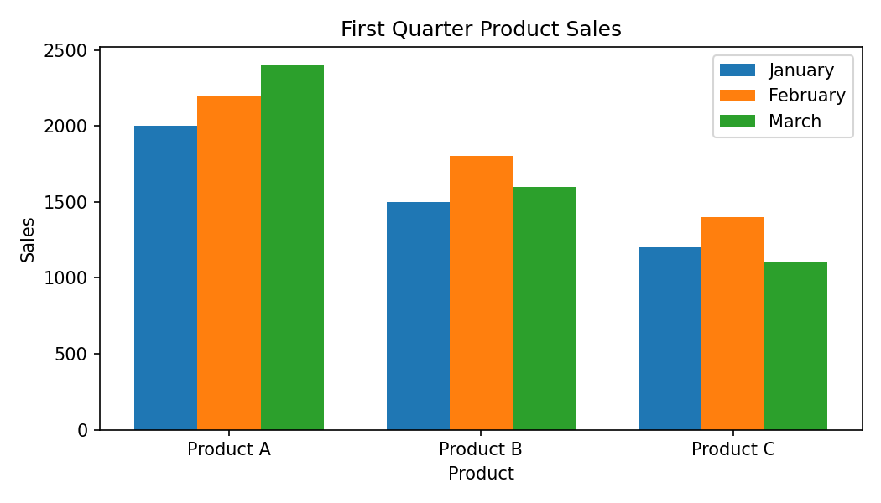
Output 1: Grouped Bar Chart of Product Sales
Observation: Product A has the highest sales in all three months. Product C has the lowest sales in each month.
PROGRAM 2: Stacked Area Chart of Overall Sales
Generate a stacked area chart to represent the overall sales trend for all products over the three months.
# Dataset
month <- c("January", "February", "March")
product_a <- c(2000, 2200, 2400)
product_b <- c(1500, 1800, 1600)
product_c <- c(1200, 1400, 1100)
sales <- rbind(product_a, product_b, product_c)
# Stacked Area Chart
matplot(1:3, t(sales),
type = "l",
lty = 1,
lwd = 2,
xlab = "Month",
ylab = "Sales ($)",
main = "Overall Sales Trend by Product",
xaxt = "n")
axis(1, at = 1:3, labels = month)
legend("topleft",
legend = c("Product A", "Product B", "Product C"),
lty = 1,
lwd = 2)
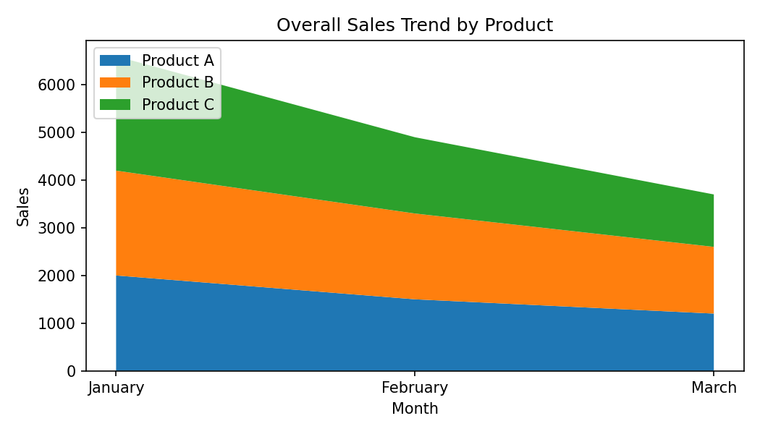
Output 2: Stacked Area Chart of Overall Sales
Observation: Product A remains the largest contributor across all three months. Product B increases from January to February and then decreases in March, while Product C also increases to February and decreases in March.
PROGRAM 3: Monthly Product Sales Table
Build a table to show the monthly sales data for each product. Label the table elements.
# Dataset
sales_data <- data.frame(
Product_ID = c(1, 2, 3),
Product_Name = c("Product A", "Product B", "Product C"),
January_Sales = c(2000, 1500, 1200),
February_Sales = c(2200, 1800, 1400),
March_Sales = c(2400, 1600, 1100)
)
# Display Monthly Sales Table
print(sales_data)
Output 3: Monthly Product Sales Table
Observation: The table displays the January, February, and March sales values for each product. Product A has the highest total first-quarter sales.
PROGRAM 4: Interactive Product Sales Dashboard
Develop a Tableau dashboard combining the grouped bar chart, stacked area chart, and the table for interactive exploration of sales data.
# Tableau Dashboard – Required Views
# 1. Create a grouped bar chart for Product Name and monthly sales.
# 2. Create a stacked area chart for Month and sales by Product Name.
# 3. Add the monthly sales table to the dashboard.
# 4. Combine all three views into one Tableau dashboard.
# 5. Add filters/actions to support interactive exploration.
# R data preparation:
sales_data <- data.frame(
Product = c("Product A","Product B","Product C"),
January = c(2000,1500,1200),
February = c(2200,1800,1400),
March = c(2400,1600,1100)
)
print(sales_data)
Output 4: Interactive Product Sales Dashboard
Observation: The dashboard combines the grouped bar chart, stacked area chart, and monthly sales table so that the first-quarter product sales can be explored together.
Set 6 Procedure
1. Create the product and monthly sales vectors from the given dataset.
2. Use barplot() with beside = TRUE to create the grouped first-quarter sales chart.
3. Use the monthly sales matrix to visualize the overall product sales trend.
4. Create a data frame and print it as the monthly sales table.
5. Import the dataset into Tableau and combine the three views into an interactive dashboard.
Set 6 Result
The monthly product sales data was successfully visualized using a grouped bar chart and a sales trend chart, and the monthly values were organized in a table. The three views can be combined in Tableau for interactive exploration.
Key R Functions Used
Function | Purpose
barplot() | Creates grouped and stacked bar charts.
plot() | Creates line and scatter plots.
matplot() | Plots multiple related data series.
rbind() | Combines vectors into a matrix by rows.
data.frame() | Creates a tabular data structure.
order() | Sorts values and helps identify top-N observations.

